Project 8: Numerical Integration

Ryan Scott and Diego Guerra

Grand Canyon University

CST-305: Principles of Modeling and Simulation

Prof. Citro

**Part 1:**Find the Reimann of f(x) = sin(x) + 1 over the interval [-π, π] 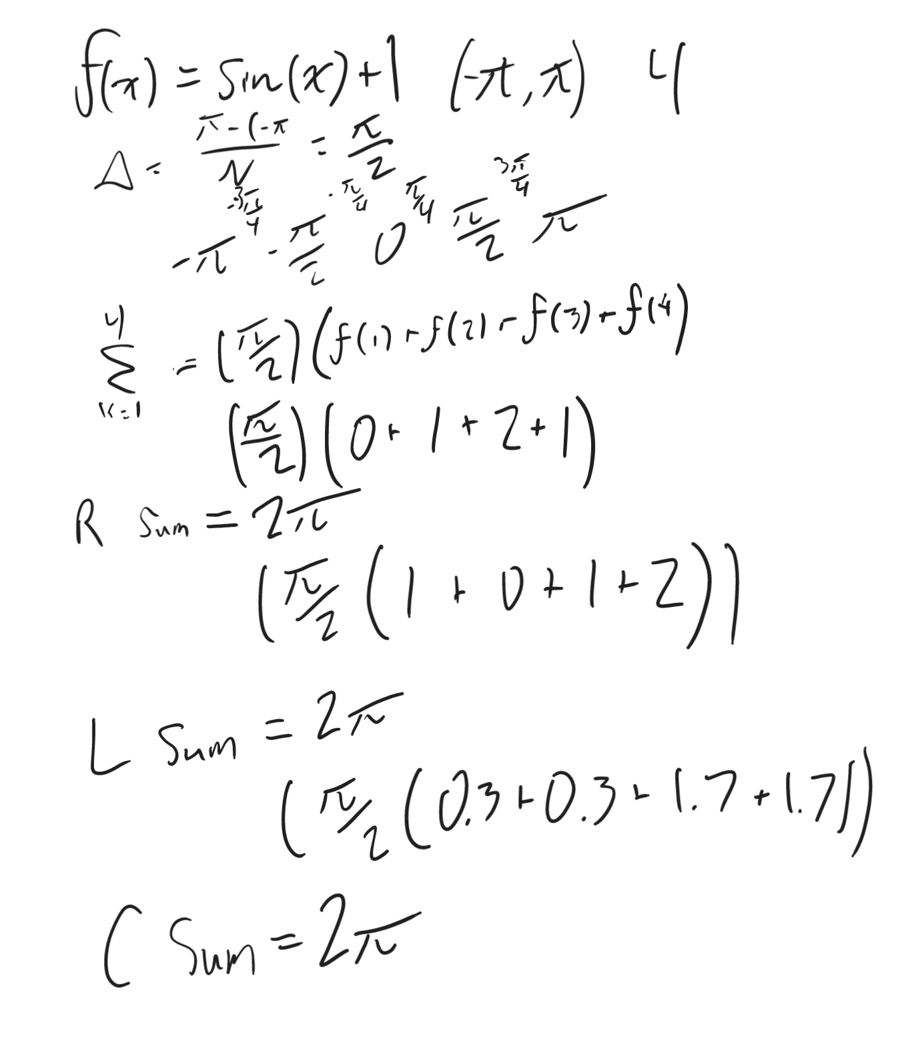

**Left Riemann Sum**

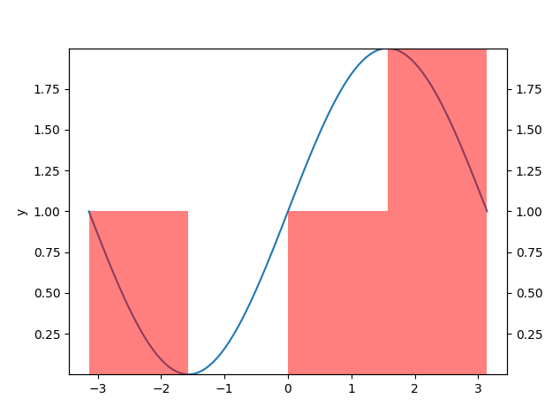

**Center Riemann Sum**

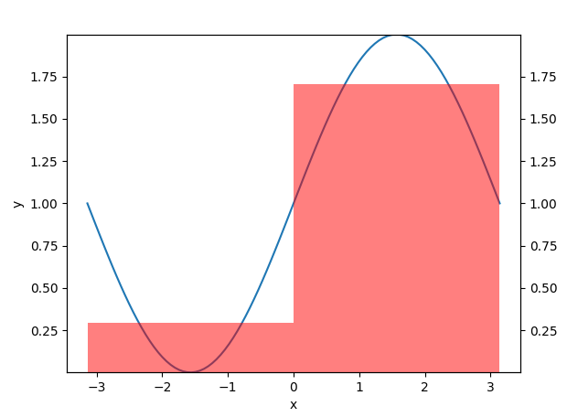

**Right Reimann Sum**

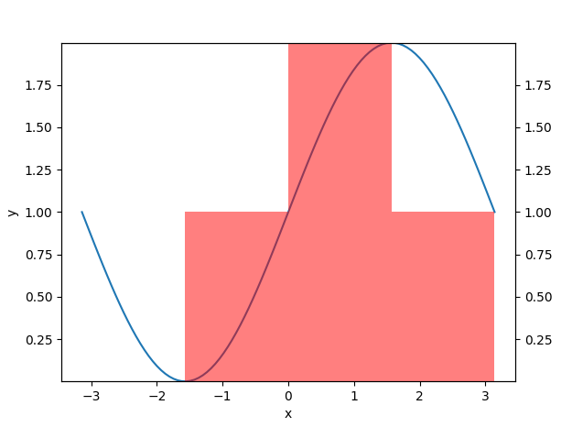

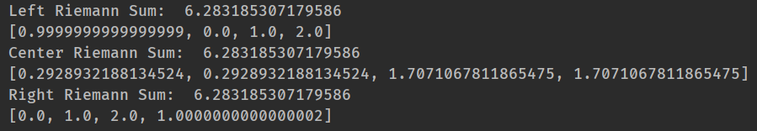

**B.   
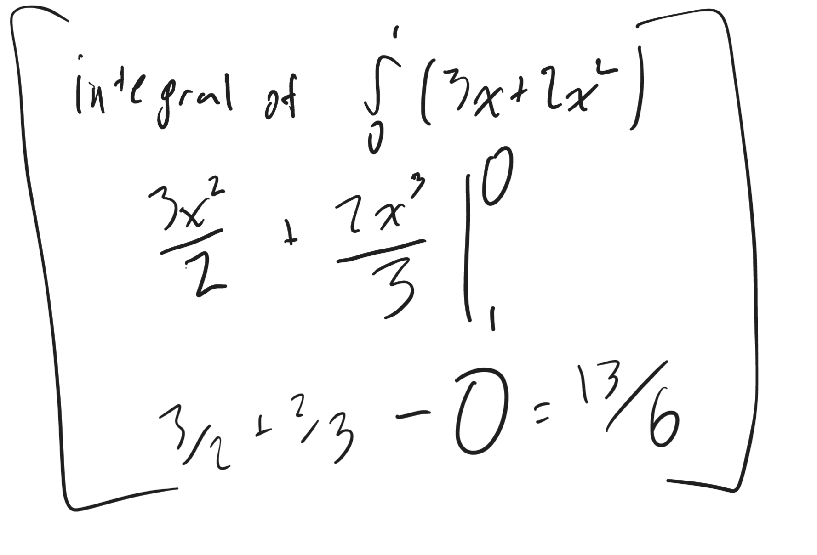**

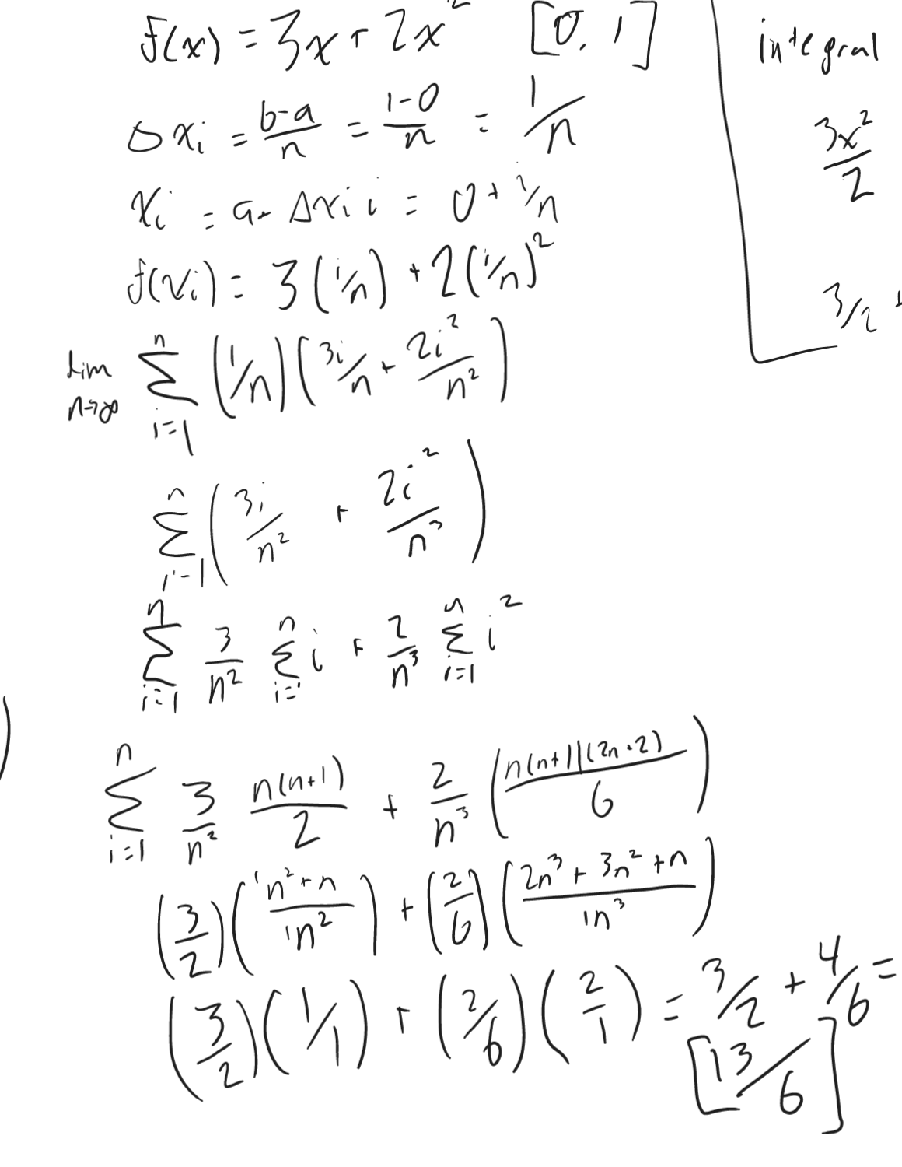

The area found in both equations is 13/6.

**C.   
 1.   
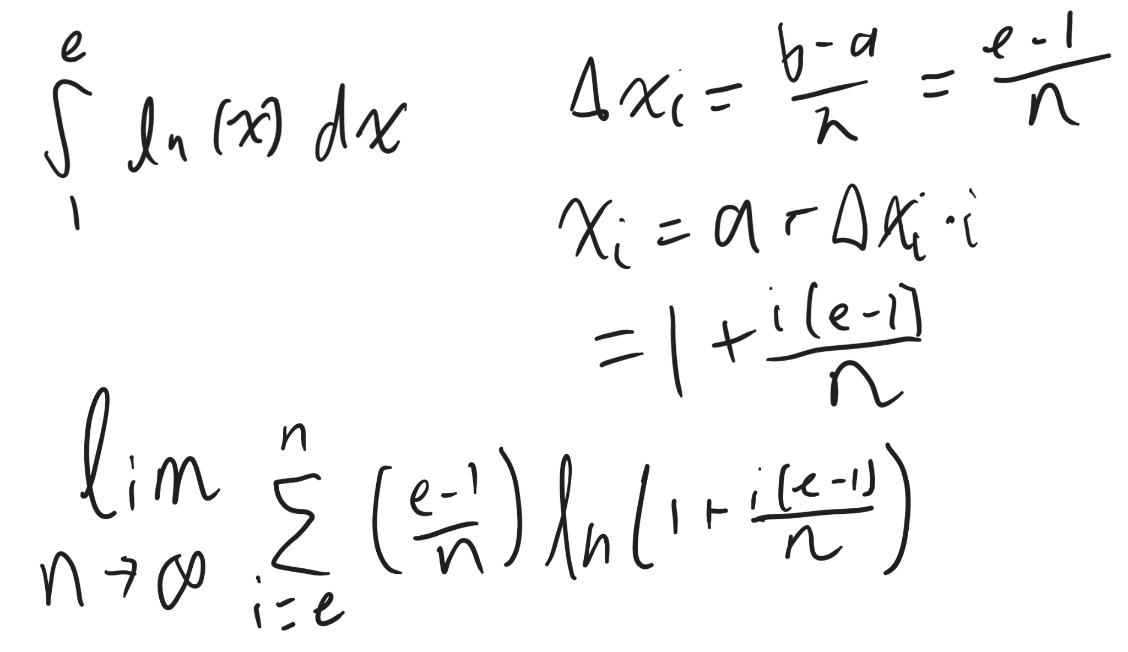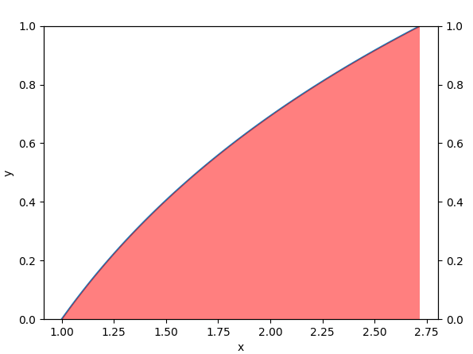  
 2.  
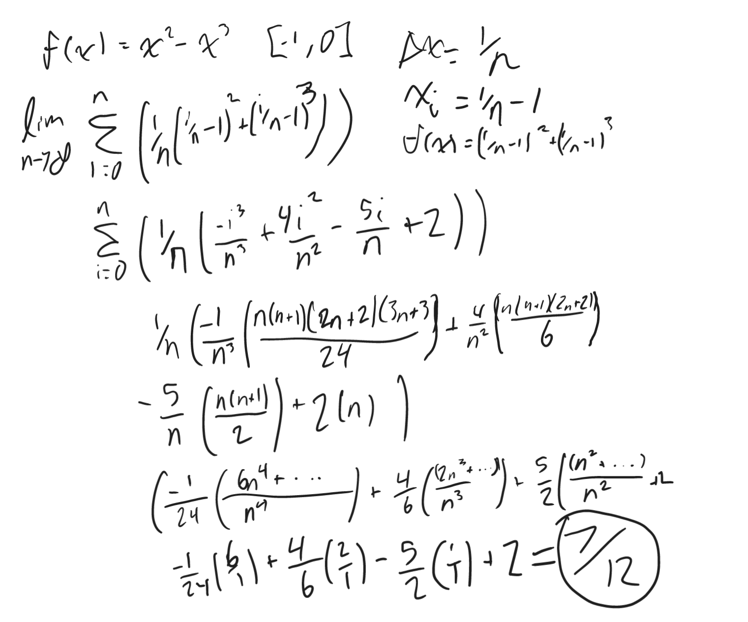**

The area found in both equations is 7/12.

**Part 2:**

The following data was gathered by downloading mp4s from YouTube using the GCU ethernet connection in Papago.

| **Minute** | **Rate(MB/s)** | **Minute** | **Rate(MB/s)** |
| --- | --- | --- | --- |
| 0 | 17.0 | 16 | 19.8 |
| 1 | 17.3 | 17 | 18.5 |
| 2 | 19.4 | 18 | 15.5 |
| 3 | 15.8 | 19 | 22.4 |
| 4 | 20.2 | 20 | 18.5 |
| 5 | 16.5 | 21 | 17.9 |
| 6 | 23.7 | 22 | 16.8 |
| 7 | 19.9 | 23 | 16.4 |
| 8 | 21.1 | 24 | 15.9 |
| 9 | 20.9 | 25 | 21.8 |
| 10 | 19.1 | 26 | 15.8 |
| 11 | 20.4 | 27 | 18.7 |
| 12 | 18.0 | 28 | 21.2 |
| 13 | 17.5 | 29 | 17.1 |
| 14 | 21.4 | 30 | 16.5 |
| 15 | 18.7 | - | - |

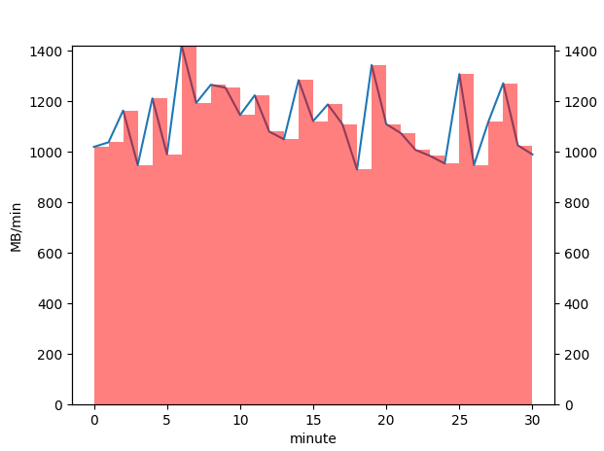

As illustrated in the graph, the line represents the number of megabytes downloaded per minute in MB/min. The area of the bars under the graph represents the number of megabytes downloaded. The sum of these bars represents the total amount of megabytes downloaded in the 30-minute period. Based on the results, I downloaded roughly 34GB of data during this period.

Using the average download speed as a constant function, it is possible to obtain an equation R(t) for this dataset. Because download speed fluctuates from one value to another as it goes up and down, it stays mostly in the same range most of the time and does not stray further from or closer to it as the download goes on. Using our Riemann sum (total data downloaded), we can divide it by 60 (to convert it back to seconds), and divide by 30 (the total number of minutes it took to download the data). This gives us the following equation:

R(t) = 18.77 MB/s